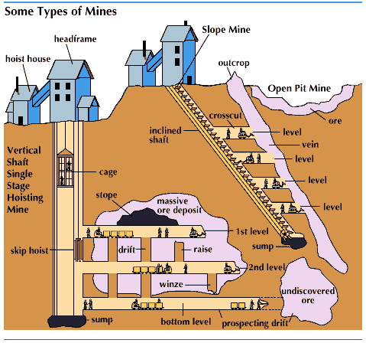
You will be putting on your research cap and undergoing a guided internet search to find out the answers to the questions found on your WebQuest worksheet. You will discover the minerals and rocks that you use or come into contact with every day. You will learn about how minerals and rocks are taken out of the ground, the different types of mining techniques, and how mining affects our environment and ourselves.
At the conclusion of this WebQuest, you will make a poster responding the following prompt: A mining company has found a precious mineral next to Garrison and want to start mining. What are the positive and negative effects of having a mine site next to your school, and would you allow the mining company to open a mine next to your school? http://zunal.com/process.php?w=146299

“Uses of Rocks and Minerals”
- Visit your first website on the uses of rocks and minerals. Document the Website here:
- On your worksheet, find the chart labeled "Important Uses of Rocks and Minerals."
- Notice that some of the chart is already filled in for you.
- Using the information from the website, fill in the rest of the chart.
The Importance of Rocks and Minerals
Name | Type of Rock | Uses
 | Sedimentary
 | Igneous
 | Metamorphic

"Rock and Mineral Uses from Rockman”
- Visit the second website resource: Rock and Mineral Uses from Rockman. http://www.rocksandminerals.com/uses.htm
- Read the first few introductory sentences.
- Answer the question below based on what you just read.
- Find the chart below labeled "Rock, Mineral, and Metal Uses."
- Using the information from the website, fill in the chart with 3 different rocks, minerals, or metals and their uses.
What is the estimated amount of rock, minerals and metals that you use during your lifetime?

Rocks, Mineral, and metal Uses
Name | Uses

“Let’s Do Some Cyber Prospecting!”
- Visit the third website resource: Let’s Do Some Cyber Prospecting! http://www.msha.gov/kids/mining.htm
- Find the chart below labeled “Cyber Prospecting!”
- On the website, click on three states and list the mineral(s) found there in the chart.
Cyber Prospecting!
State | Mineral(s) Found

“Some Types of Mines”
- Visit the fourth website resource: Some Types of Mines. http://kids.britannica.com/comptons/art-53672/The-diagram-depicts-a-cross-section-of-three-different-kinds
- Look at the diagram and take note of the different types of mines.
- Using the information from the diagram, answer the question below.
What are three different types of mines?

“Mining 101: The Importance of Mining”
- Visit the fifth website resource: Mining 101. http://www.mii.org/pdfs/MiningImportance.pdf
- Before going through the slideshow, read the questions below to know what information you’re looking for.
- Using the information from the slideshow, answer the questions below.
What is the first step of mining called?

When thinking about the environmental impact, before a mine can be opened what must be completed?

What are some positives that mining bring to people and towns?

What is reclamation and what does it do to mined land?

Compare the before and after pictures of reclaimed mines. What do you notice about the before pictures? What do you notice about the after pictures?

“Sweet Child of Mine: The Effects of Strip Mining on the Children in the Appalachia”
- Visit the sixth website resource: Sweet Child of Mine: The Effects of Strip Mining on the Children in the Appalachia. http://zunal.com/process.php?w=146299
- Read the question below before watching the video.
- Using the information from the diagram, answer the question below.
Write your response to the video. What negatives aspects to mining did you notice?

The final task of this WebQuest is to apply what you have learned about the positive and negative effects of mining and in small groups make a poster to present to the class.
You specially will be making a poster in response to the following prompt:
A mining company has found a precious mineral next to your school and want to start mining. What are the positive and negative environmental and/or human effects of having a mine site next to your school. Also include whether or not you would allow the mining company to open a mine next to your school. Take a stand and remember to back it up with specific examples from your WebQuest research!
You will be graded based on the rubric below.
 | 1 - Beginning | 2 - Intermediate | 3 - Advanced | 4 - Exemplary | Score
Negative Effects | Vaguely describes 5 negative environmental and/or human impacts | Partially describes 5 negative environmental and/or human impacts | Clearly describes 5 negative environmental and/or human impacts | Clearly describes and explains 5 negative environmental and/or human impacts
Positive Effects | Vaguely describes 5 positive environmental and/or human impacts | Partially describes 5 positive environmental and/or human impacts | Clearly describes 5 positive environmental and/or human impacts | Clearly describes and explains 5 positive environmental and/or human impacts
Poster Organization | Difficult to read. No variance of color. Lacks organization. | Legibly written. Lacks variance of color. Impacts are progressing towards organization. | Legibly written. Demonstrates limited variance of color. Impacts are somewhat organized. | Clearly written with enough variance of color to be seen throughout the room. Impacts are clearly organized.
Presentation | Voice is projected and clear. Faces audience with good posture. Able to fully answer audience's questions. Student completes one of the above criteria. | Voice is projected and clear. Faces audience with good posture. Able to fully answer audience's questions. Student completes two of the above criteria. | Voice is projected and clear. Faces audience with good posture. Able to fully answer audience's questions. Student completes three of the above criteria. | Voice is projected and clear. Faces audience with good posture. Able to fully answer audience's questions. Student completes four of the above criteria.

